SAMAView – Creating a Public User Account

- Enter https://mysama.ca/account/login in your browser address bar.
- Click on “Don’t have an account? Sign up now”, located below Sign Up.
- Click on Public User. Commercial users (Private appraisers, banks, businesses, and realtors) must sign up for an Organization account.
- Complete all Sign Up fields, click on I’m Not A Robot, then click the button “Sign up.”
- You will immediately receive a verification email from Portal Notification.
- Click “Please click here” to verify your email address.
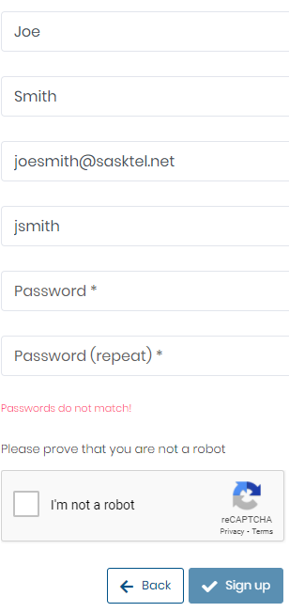
- You will be taken to the Public User Log In page. Re-enter your email and password, and you are all set to use MySAMA.
