Summer Activity List 2022

- Sweet Treat Day- Wednesday, July 20th
- Scavenger Hunt- Tuesday, July 26th
- Water Wars- Thursday, July 28th
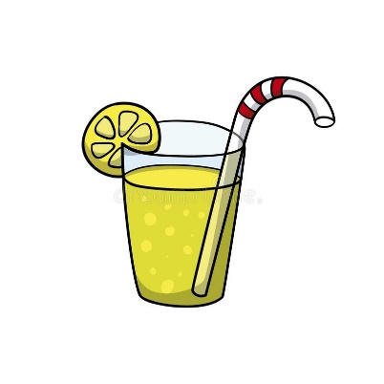
- Garden Fairy Day- Thursday, August 4th
- Science Day- Tuesday, August 9th
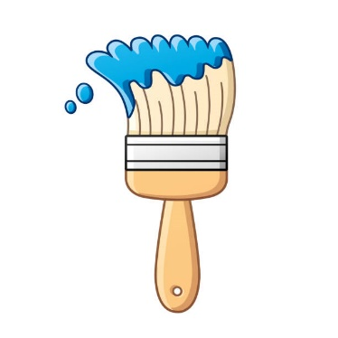
- Lemonade Stand- Wednesday August 10th
- Tie Die Day- Tuesday, August 16th
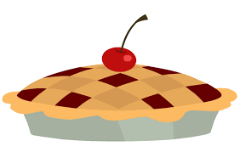
- Ultimate Obstacle Course and Kickball Day- Thursday, August 18th
- Craft Day- Tuesday, August 23
10. Old Fashion Family Fun Day- Friday, August 26th

